**Project Design Phase-II**

**Data Flow Diagram & User Stories**

|  |  |
| --- | --- |
| Date | 13 October 2022 |
| Team ID | PNT2022TMID23612 |
| Project Name | Project - A Novel Method For Handwritten Digit  Recognition System |
| Maximum Marks | 4 Marks |

**Data Flow Diagrams:**

A Data Flow Diagram (DFD) is a traditional visual representation of the information flows within a system. A neat and clear DFD can depict the right amount of the system requirement graphically. It shows how data enters and leaves the system, what changes the information, and where data is stored.

Example: DFD Level 0 (Industry Standard)

**Example: [(Simplified)](https://developer.ibm.com/patterns/visualize-unstructured-text/)**

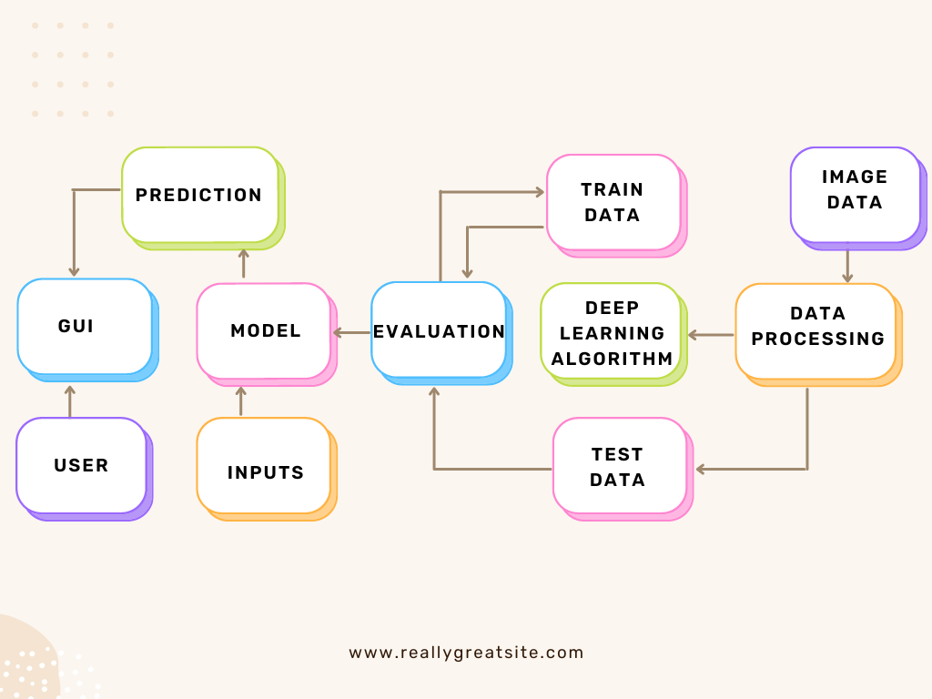

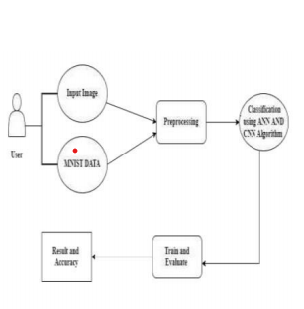

**User Stories**

Use the below template to list all the user stories for the product.

| **User Type** | **Functional Requirement (Epic)** | **User Story Number** | **User Story / Task** | **Acceptance criteria** | **Priority** | **Release** |
| --- | --- | --- | --- | --- | --- | --- |
| Customer (Mobile user) | Registration | USN-1 | As a user, I can register for the application by entering my email, password, and confirming my password. | I can access my account / dashboard | High | Sprint-1 |
|  |  | USN-2 | As a user, I will receive confirmation email once I have registered for the application | I can receive confirmation email & click confirm | High | Sprint-1 |
|  |  | USN-3 | As a user, I can register for the application through Facebook | I can register & access the dashboard with Facebook Login | Low | Sprint-2 |
|  |  | USN-4 | As a user, I can register for the application through Gmail | I can register the  application with Gmail. | Medium | Sprint-1 |
|  | Login | USN-5 | As a user, I can log into the application by entering email & password | I can login to the application. | High | Sprint-1 |
|  | Dashboard | USN-6 | As a user, I can view the dashboard and read the steps to use the application | I can use the application as it is user-friendly. | Low | Sprint-1 |
|  | Upload Image | USN-7 | As a user, I can give the digital documents as an input to the application. | I can give input of digital documents to the application. | High | Sprint-3 |
|  | Predict | USN-8 | As a user, I can get the recognized digits as output from the given digital documents as input. | I can get the digits as output from given input of digital documents. | High | Sprint-3 |
|  |  | USN-9 | As a user, I will train and test the input as much got getting maximum accuracy of output. | I can train and test the input until the result is of maximum accuracy. | Medium | Sprint-4 |
| Customer(Web user) | Accessibility | USN-10 | As a user, I can use the web application anywhere virtually. | I can use the application in any device which consists of a browser. | Medium | Sprint-4 |